CS522 – Big Data

SPARK PROJECT – PART 5

Maharishi University of Management

Department of Computer Science

**Students**: Thi Luong Dinh 985443

Dinh Tan Luong 985408

November 20th, 2016

# First Scala Spark Project

Get the guide from below links:

<http://www.tutorialspoint.com//apache_spark/index.htm>

<http://scala-ide.org/docs/videos.html>

## Verifying Java Installation

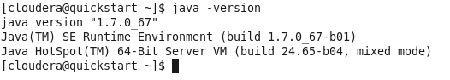

## Verifying Scala installation



## Install Scala

Install Scala from Eclipse by select **Help 🡪 Install New Software…**

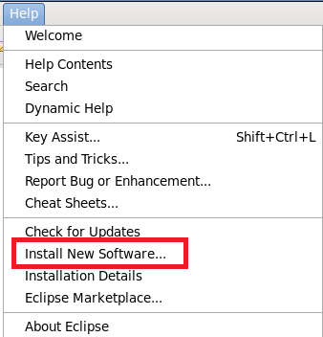

Give a name and put the location to **http://download.scala-ide.org/sdk/lithium/e44/scala211/stable/site**

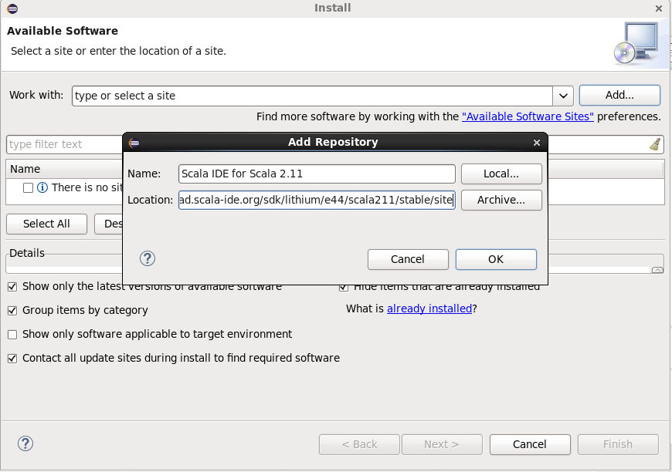

Select Scala IDE for Eclipse:

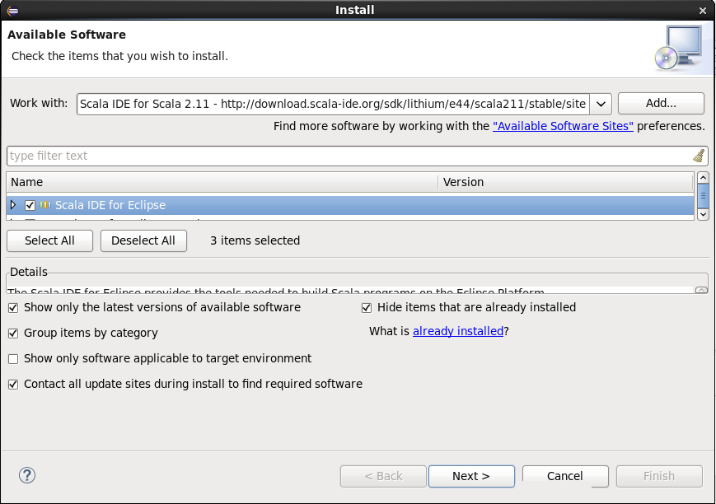

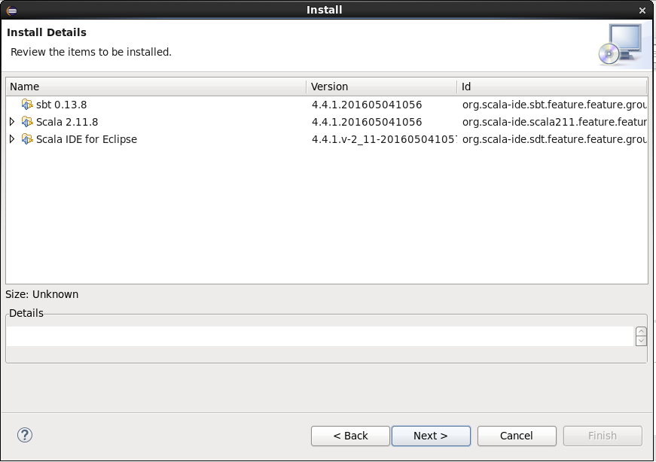

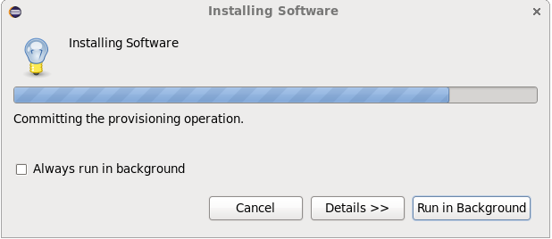

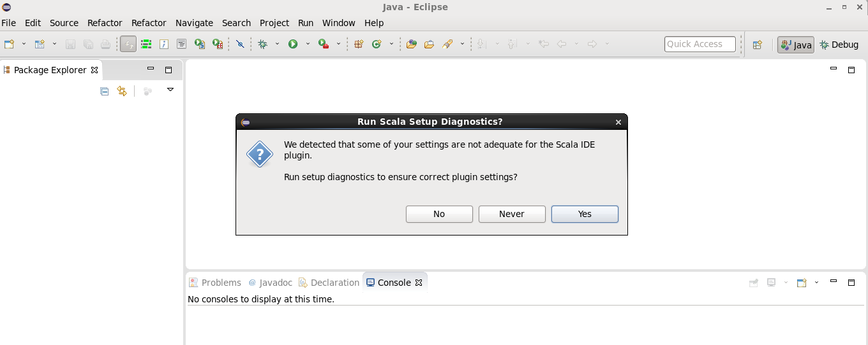

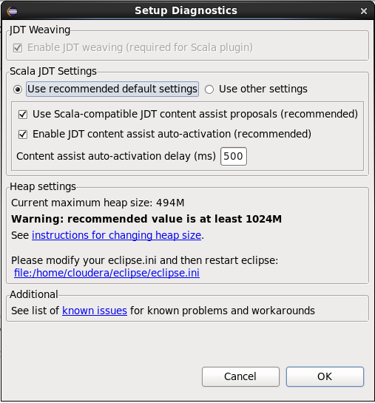

## Create a sample Scala project

Select **File 🡪 New 🡪 Scala Project**

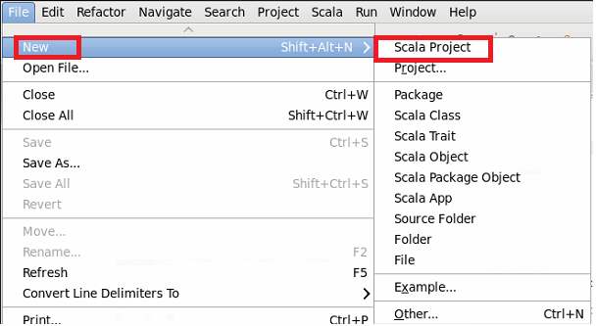

Enter the project name and click **Finish**

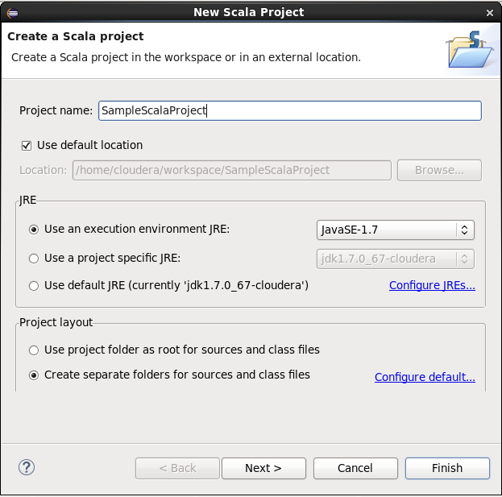

The new project was created:

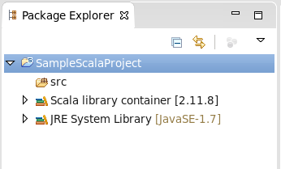

Add new Scala Object:

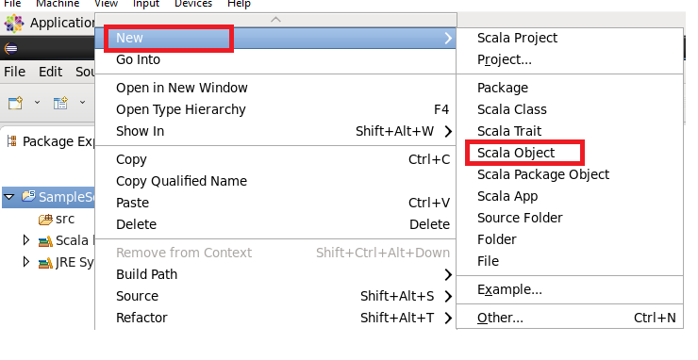

Enter name for the object:

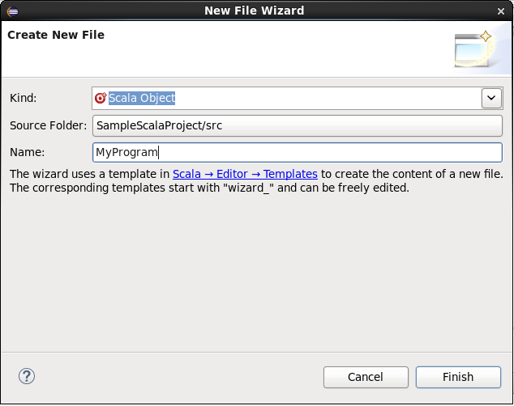

Enter the code to print out the text “Scala rocks!”

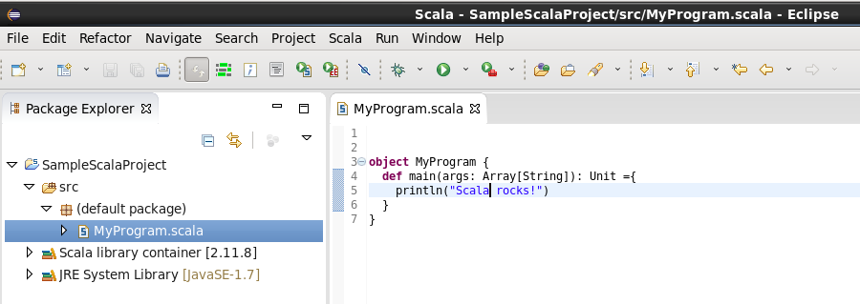

Run the project by clicking button Run:

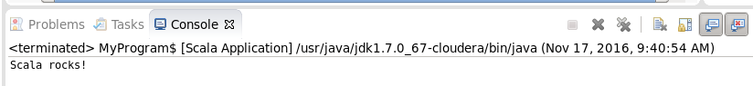

# Spark Project

## Get the sample code:

Get the sample code from: https://github.com/alvinj/ScalaApacheAccessLogParser

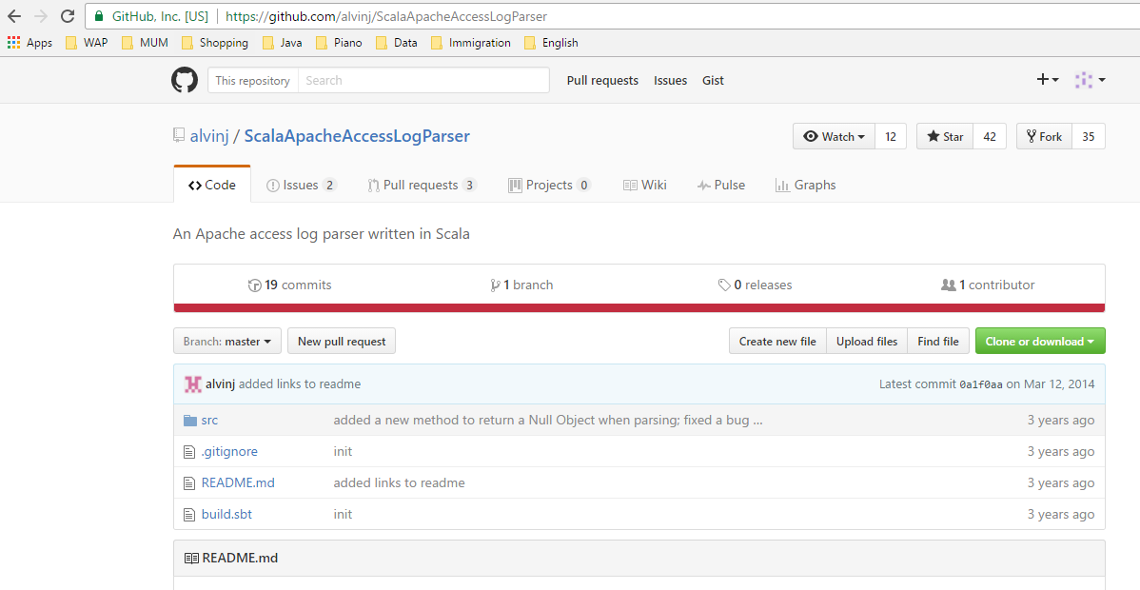

## Develop code

Write **LogAnalytics.scala** to do some calculation on the log:

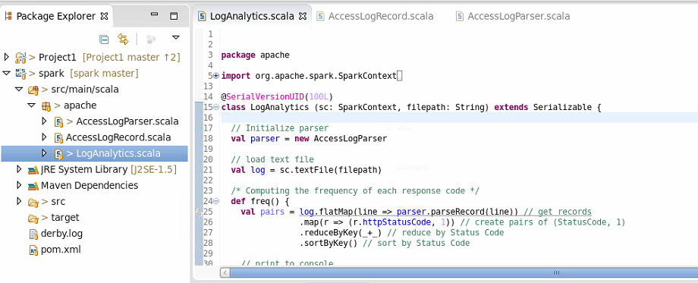

## Run the project

Export the project to jar file:

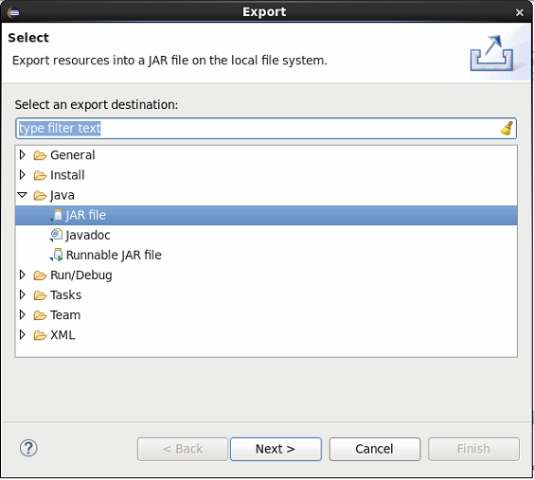

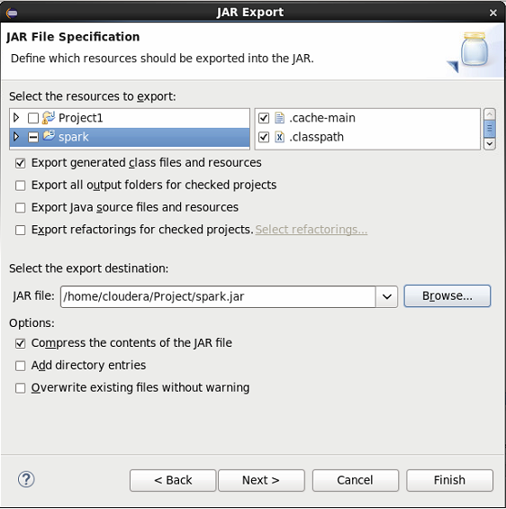

Use spark-shell command to deploy the jar file:

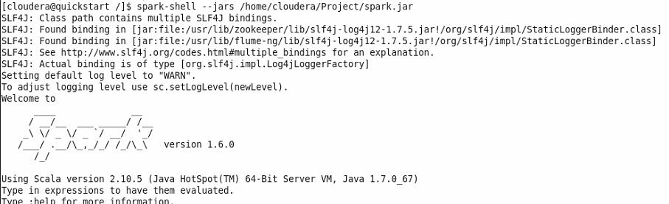

**Run some functions of in the LogAnaylytics.scala:**

Get the access_log file from <http://www.monitorware.com/en/logsamples/apache.php> and put it the input folder of Hadoop.

Import the Scala object LogAnalystics and use it:

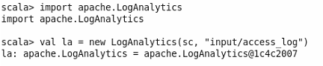

**Compute the frequency of each response code**

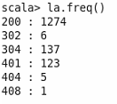

**All IP Addresses that have accessed this server more than 20 times**

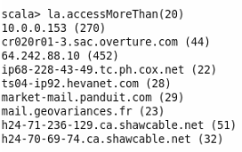

**The top 25 endpoints requested by count**

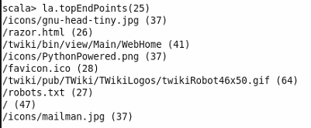

**Calculate the average, max, min size of the content size**

